### Kubernetes for Dummies, Literally!

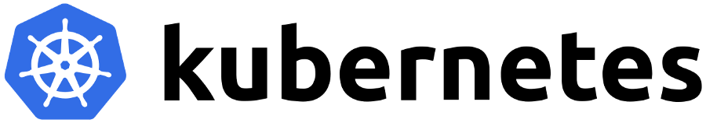

Kubernetes, an often coupled technology with Docker, was something I wanted to write about after receiving a lot of response on my piece “[Docker for rookies 🐳](https://medium.com/@devangtomar/how-to-get-started-with-docker-b2d924cbe9bb)” If you haven’t already, please read Docker for Rookies 🐳 [here](https://medium.com/@devangtomar/how-to-get-started-with-docker-b2d924cbe9bb). Knowing how to use a container service like Docker is essential for understanding Kubernetes. Actually, Kubernetes can manage more container runtimes that are not addressed in this article. In this article, I’ll describe Kubernetes, the issues it uses containers to address, and how you can start utilizing it right away.

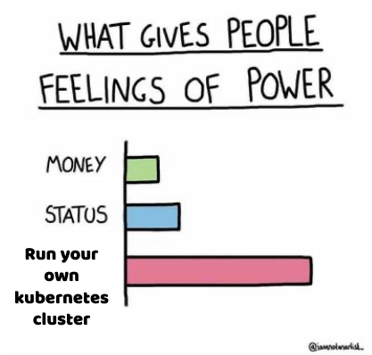

Kubernetes successfully manages containerized apps by automating procedures. It is not, however, as easy to use as it first appears. A full understanding of Kubernetes’ operation is crucial because dealing with it and its deployment process presents security concerns as well. You may learn more about Kubernetes in this post, including its advantages and disadvantages as well as how to implement it properly. Let’s look more closely.

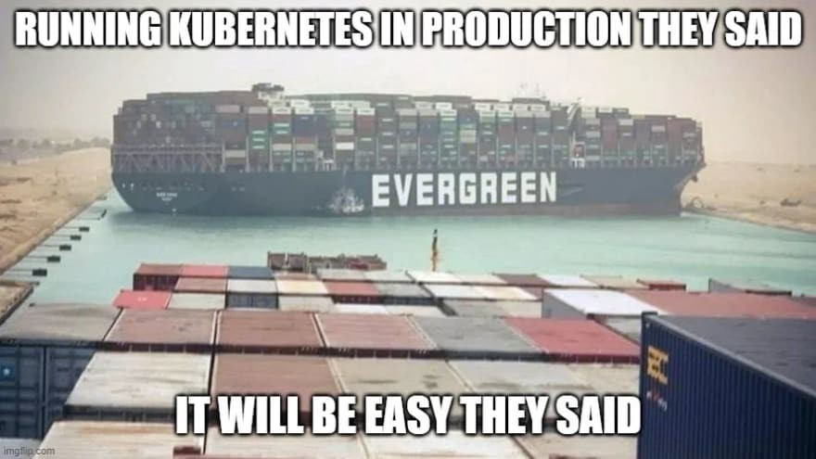

### An Overview of Kubernetes 🆕

The name Kubernetes is taken from the Greek word κυβερvήτης (kubernḗtēs), which meaning helmsman or pilot. The ship’s wheel in the Kubernetes logo reinforces the sense of managing or piloting, which is precisely what Kubernetes accomplishes with Docker containers. It is not necessary to manage Docker containers manually because Kubernetes handles them in a number of ways. Due to the 8 characters between “K” and “s,” Kubernetes is frequently abbreviated as “K8s” for convenience. From this point forward, I’ll refer to Kubernetes as K8s.

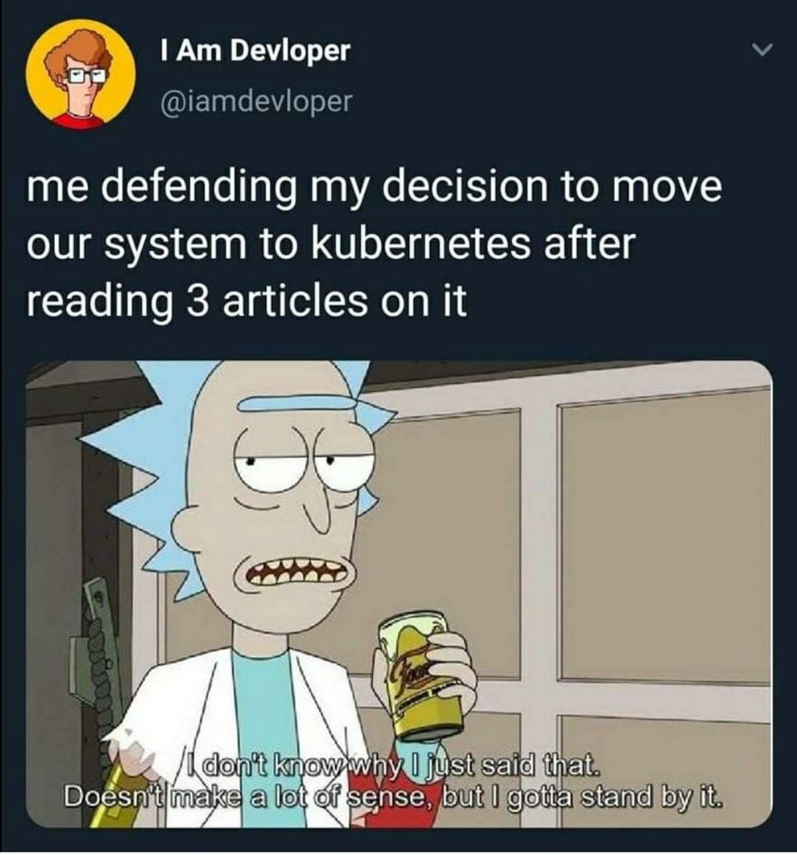

The use of K8s further decouples networks, storage, and machines from their actual physical implementation. Managing several containers manually might lead to problems comparable to managing virtual machines, as was mentioned in the previous piece. However, since cloud providers charge you for things like compute time and storage, controlling containers is very crucial. For this reason, you don’t want to have a lot of idle containers running. Additionally, you don’t want one container to take on more network load than it can manage on its own. K8s was created to address issues like these.

### What services does K8s provide? 🤔

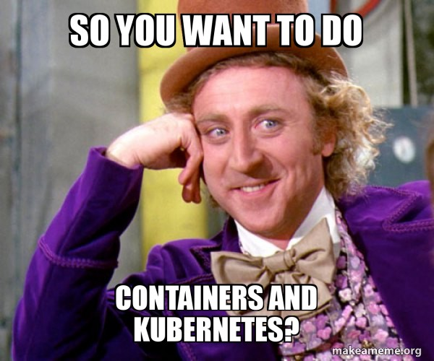

* **Service discovery and load balancing :** In order to stabilize deployments, K8s can route network traffic to other containers and locate a container using a DNS name or IP address.
* **Secret and configuration management :** You may save private data with K8s, including passwords, OAuth tokens, and SSH keys. Without having to rebuild your container images or expose secrets in your stack settings, you may update these secrets and the app configuration.
* **Self-healing :** K8s kills containers that don’t respond to your user-defined health check, restarts failing containers, and doesn’t advertise them to clients until they are prepared to serve.
* **Automatic bin packing :** To perform containerized processes, you can provide K8s a cluster of nodes and specify the CPU and memory requirements for each container. To optimise resource usage, Kubernetes can automatically fit containers onto nodes.
* **Storage orchestration :** Any storage system you choose can be automatically mounted, whether it is local, hosted by a cloud service like AWS or GCP, or on a network storage system like NFS iSCSI, Gluster, Ceph, Cinder, or Flocker.
* **Automated rollouts and rollbacks :** Deployed containers can be defined in the desired state, and the state can be changed at a regulated rate. For instance, Kubernetes can be automated to generate new containers for your deployment, remove any already present containers, and adopt all of the resources from the old containers to the new ones.

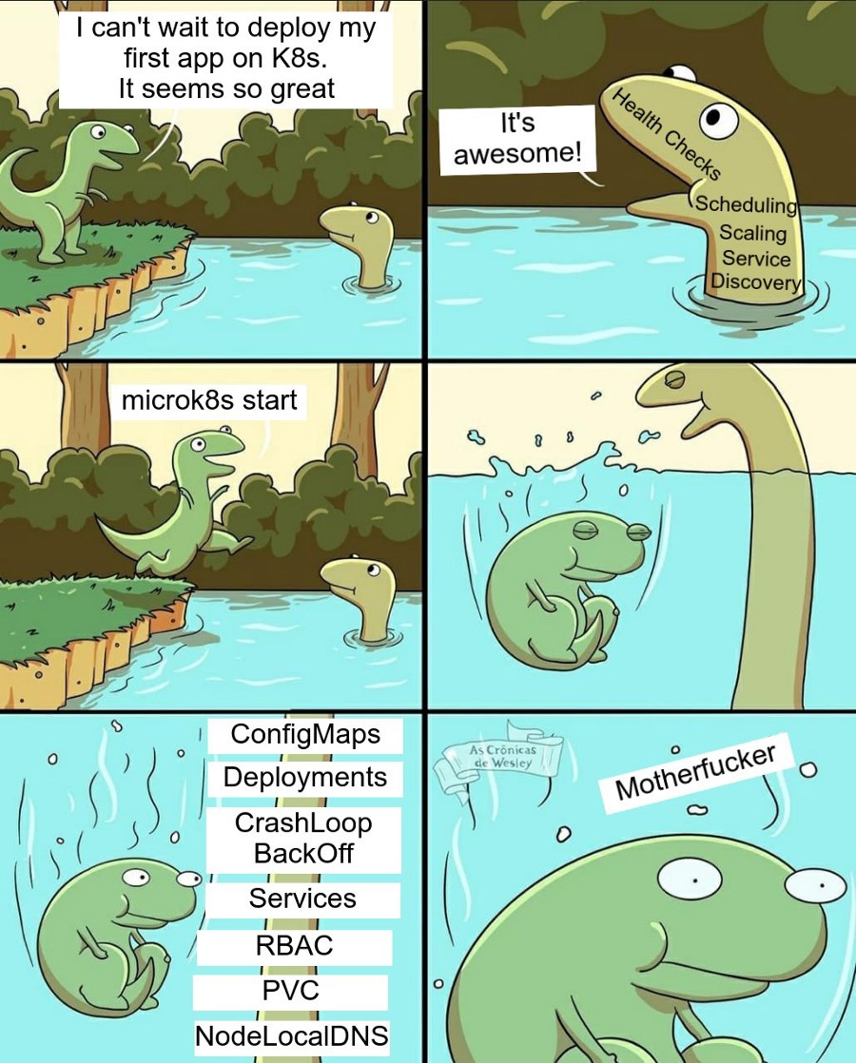

In this article, we’ll simply touch the surface of these features.

### Some Definitions 📃

It’s crucial to comprehend these fundamental K8s ideas. Once more, before moving on, you should be conversant with container services like [Docker](https://medium.com/@devangtomar/how-to-get-started-with-docker-b2d924cbe9bb).

* **Pods :** Groups of one or more containers make up pods. Pods have shared network and storage resources with rules for how to operate containers. They are the tiniest deployable computer units that K8s can generate and operate. Pods operate as a logical unit on nodes as a group, meaning they all have the same IP address but can communicate via localhost. Pods can share storage, but since containers can run on different machines, they are not required to run on the same machine.

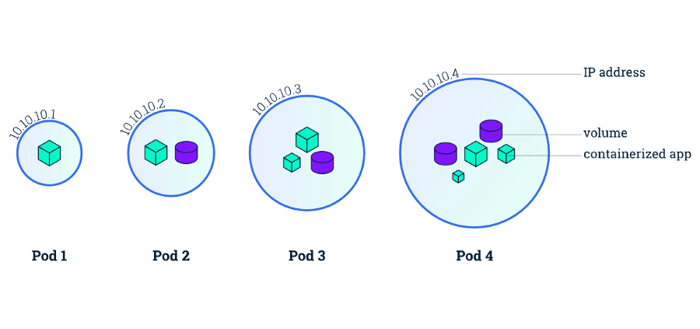

* **Nodes :** Physical or virtual machines that are not made by K8s are known as nodes. In a cluster, you would typically have numerous nodes, however in a learning environment or one with restricted resources, you might only have one node. Before using K8s to deploy applications, you must have basic infrastructure in place because nodes are established manually or using public cloud services like AWS EC2 or OpenStack. From here, you may define storage, virtual networks, etc. Several pods can run on a single node.

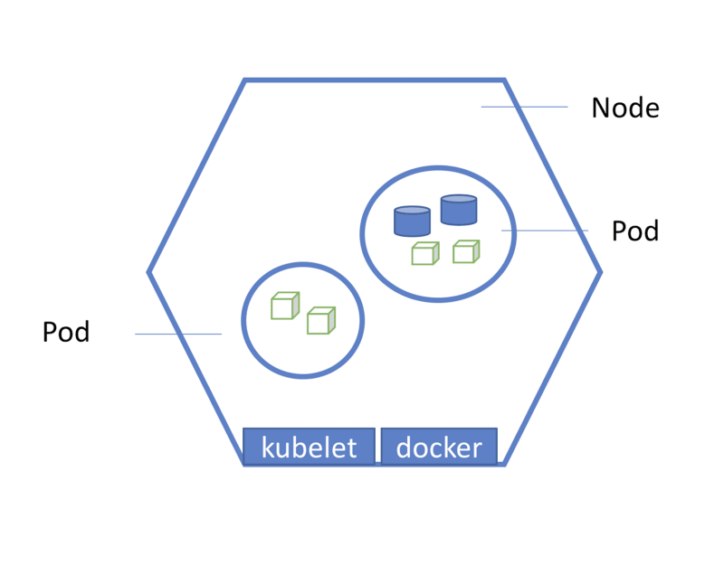

* **Deployments :** A group of Pods make up a deployment. A deployment makes sure that there are enough active Pods to support the app at once. By taking a look at data like CPU use, deployments can also shut down Pods that are not required.

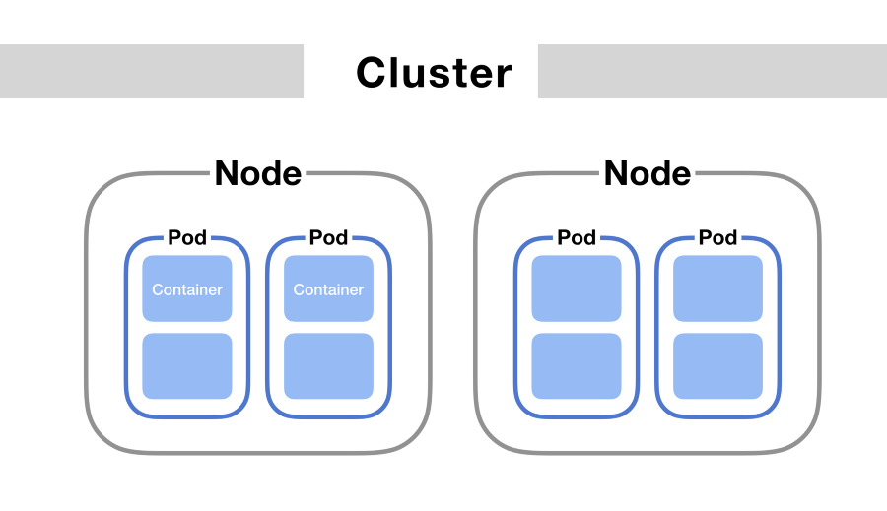

### Let’s begin to use K8s ⭐

For easy setup just get **Docker Desktop** onyour machine. Link to it is below :

**Docker Desktop :** <https://www.docker.com/products/docker-desktop/>

I’ll be utilizing **Minikube** and **Kubectl** to run K8s locally. The most recent versions of Minikube and Kubectl can be installed using :

Minikube : [*https://minikube.sigs.k8s.io/docs/start/*](https://minikube.sigs.k8s.io/docs/start/)

Kubectl : [*https://kubernetes.io/docs/tasks/tools/*](https://kubernetes.io/docs/tasks/tools/)

Please be aware that in order to continue with this tutorial, you must also have [Docker](https://docs.docker.com/engine/install/) installed.

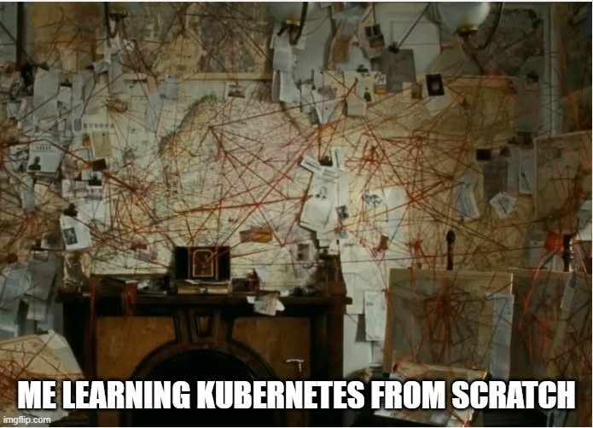

#### 1. Install prerequisites ⚙️

Use docker --version and minikube version and kubectl version We will deal with the notification that says the connection to localhost:8080 was rejected later, so don’t be concerned.

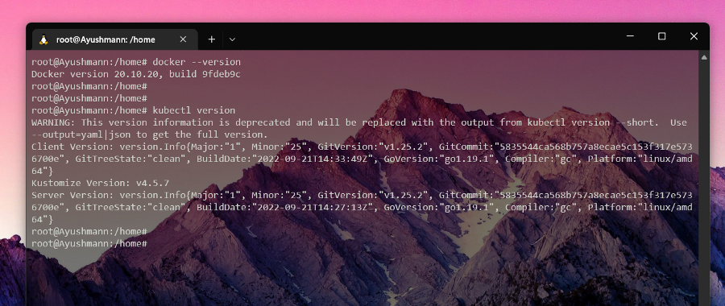

**Note :** Skipping Minikube’s version as I’m using Docker Desktop for k8s cluster setup.

#### 2. Creating a deployment 🏗️

By executing kubectl get pod, we can see the Pods. You shouldn’t have any pods at this time, and it will say “No resources detected in default namespace.”

The smallest component of the K8s cluster is the pod, however in actual use, deployments are what are created.

The command to use create a **kubernetes deployment** is :

kubectl create deployment <NAME> --image=<image>

Now we will create a nginx deployment for this specific deployment:

kubectl create deployment nginx-depl --image=nginx

**Note :** NGINX is an open-source webserver that is used to create server-side applications, for those who are unaware.

Now, the output we get from running :

kubectl get deployment

and

kubectl get pod

is as follows.

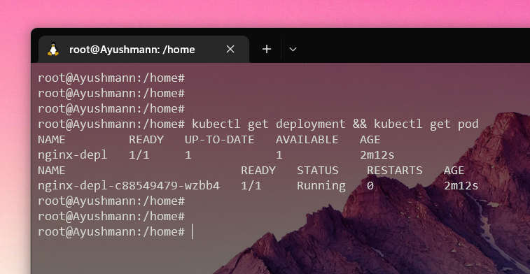

Our usage of :

kubectl create deployment <NAME> --image=<image>

This is the simplest method of creating a deployment. The deployment continues with the default settings. **ReplicaSet** is a layer between the deployment and the pod that is automatically managed by K8s deployment.

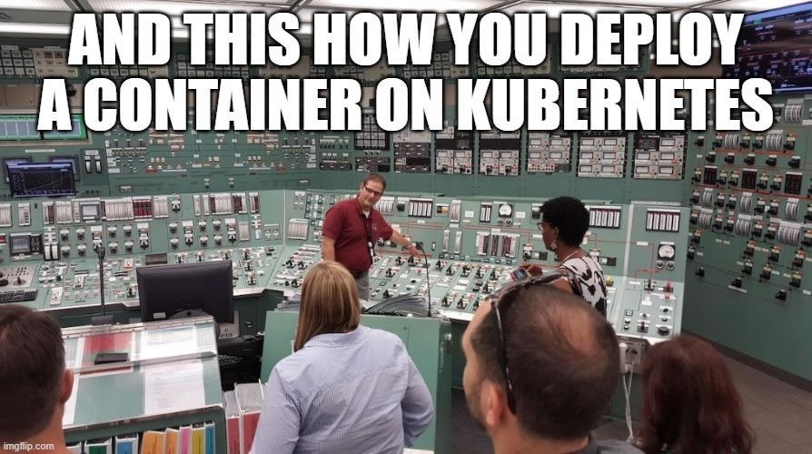

The **ReplicaSet** describes how to find Pods that it can acquire, how many Pods it should be maintaining, and the data for new Pods that should be created to satisfy the number of replicas need. In order to attain the specified number, a **ReplicaSet** creates and deletes Pods as necessary. A **ReplicaSet** uses its Pod template to produce new Pods when necessary.

We can view the **ReplicaSet** with :

kubectl get replicaset

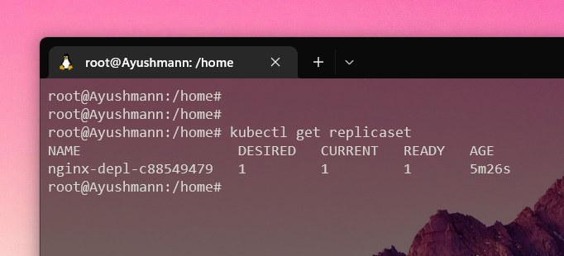

The ReplicaSet ID, c88549479, is visible after the deployment name. As was previously stated, the ReplicaSet is a layer that resides between the Deployment and the Pod. You may have noticed that the ReplicaSet ID is contained in the ID for the Pod.

In summary, this is how Abstraction’s layers function. A Pod is an abstraction of a container, and a Deployment controls a ReplicaSet, which manages all the replicas of the Pod.

#### 3. Edit the Deployment 🔨

Change your deployment utilising:

kubectl edit deployment nginx-depl

The automatically created configuration file will be displayed. Rest assured that you are not required to comprehend every detail of the configuration file at this time. We will just modify the picture version of the file, which is located somewhere in the centre, for the purposes of this tutorial.

**Previously**

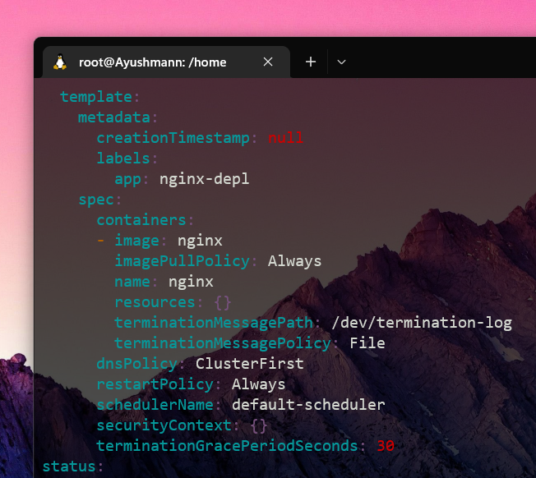

Now

Notice the nginx image version change to 1.19 :

nginx:1.19

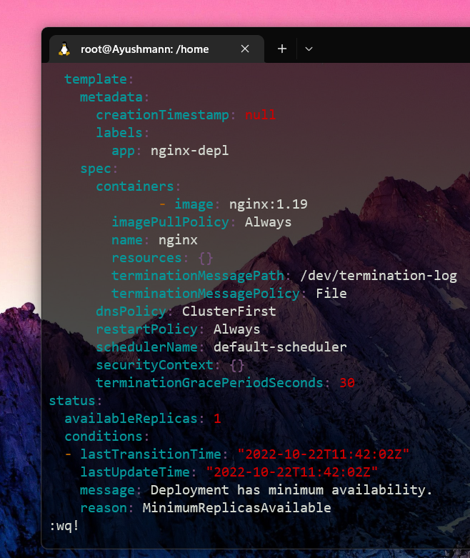

When you are finished editing, type :wq for write & quit. By doing this, the old picture will be terminated and a new one made.

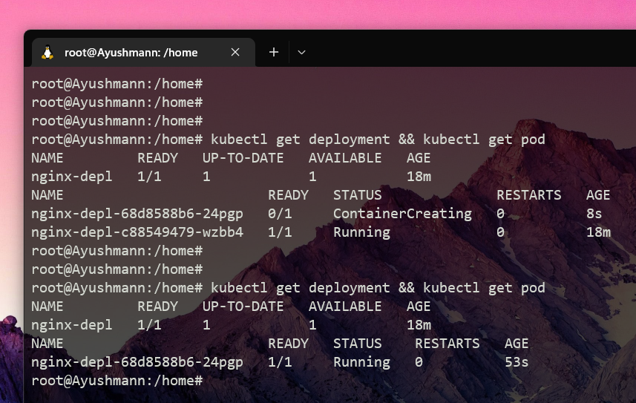

We can see that the old replicaset has no pods in it and a new one has also been formed after using the kubectl get replicasetcommand.

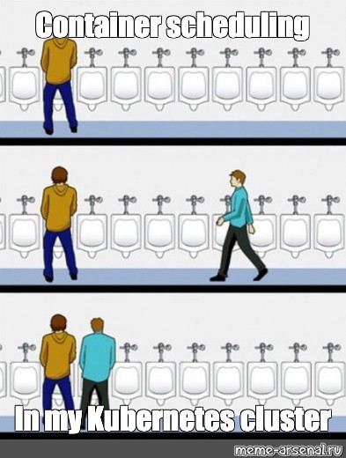

#### 4. Debugging Pods 🧑🏻‍💻🐛

Another useful command is :

kubectl logs <Pod Name>

Because nginx did not log anything, you will receive nothing if you run this on it. We can utilise MongoDB, a document database, to show off logs.

kubectl create deployment mongo-depl --image=mongo

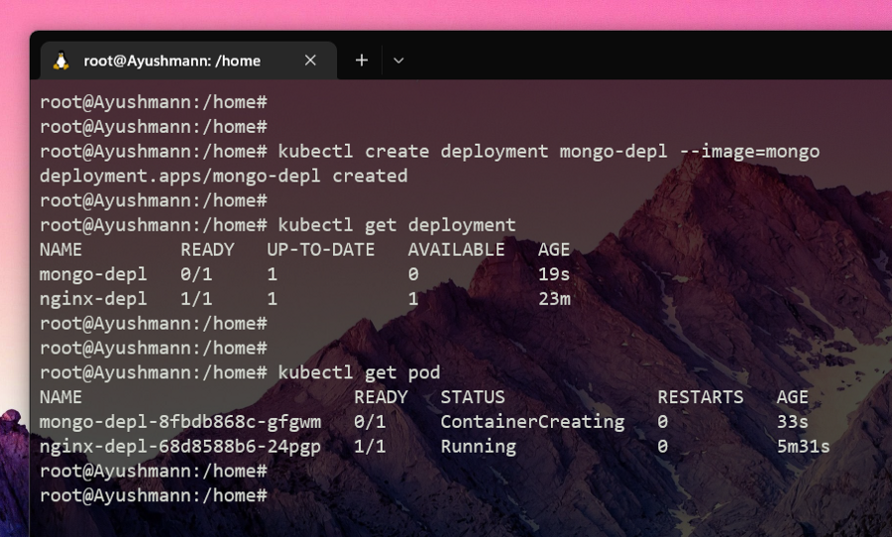

Now executing kubectl logs mongo-depl-8fbd868c-gfgwmwill produce concise logs and kubectl describe pod mongo-depl-8fbd868c-gfgwmwill produce a more verbose output.

If something goes wrong, logging will assist with debugging, and description creates something a little more understandable.

Another useful command to see what is going on inside the Pod is (-it stands for interactive terminal) :

kubectl exec -it <Pod Name> --bin/bash

Consider how we might use this to access our MongoDB pod:

kubectl exec -it mongo-depl-8fbd868c-gfgwm --bin/bash

and if we echo inside and do all sort of commands inside it. To exit this, simply type exit.

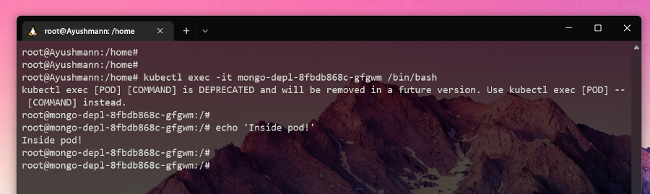

#### 5. Deleting deployments ❌☠️

All of the Pods contained in a Deployment are deleted when the Deployment is deleted. To remove, as an illustration, the MongoDB Deployment type :

kubectl delete deployment mongo-depl

**WARNING**! : You should be careful not to delete anything significant or on production clusters while using the following instructions.

With this command, all the pods in a single namespace can be deleted :

kubectl delete --all pods --namespace=foo

You can also delete every deployment in a namespace, which will also destroy every pod associated with that namespace’s deployments.

kubectl delete --all deployments --namespace=foo

With this command, you can delete all namespaces and all objects within each namespace (but not unnamespaced objects like nodes and some events) :

kubectl delete --all namespaces

The last command, however, is probably not something you want to use because it would destroy items from the kube-system namespace, rendering your cluster useless.

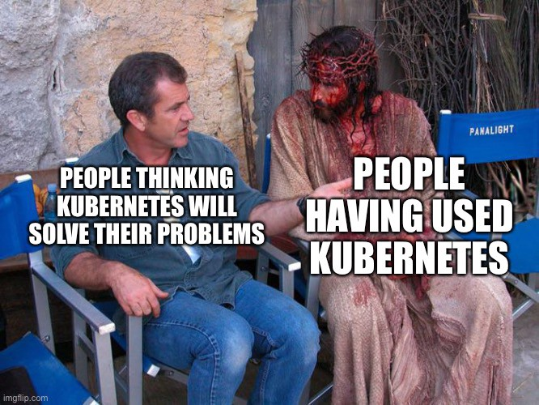

With the exception of kube-system, this command will erase all namespaces, which may be useful:

for each in $(kubectl get ns -o jsonpath="{.items[*].metadata.name}" | grep -v kube-system);

do

kubectl delete ns $each

done

#### 6. Apply configuration files 📂

We must first generate a configuration file before we can apply it. Make a configuration file for the nginx deployment and save it in a place you can access again.

touch nginx-deployment.yaml

Next, paste the following settings into the file :

**apiVersion: apps/v1**

**kind: Deployment**

**metadata:**

**name: myapp**

**labels:**

**app: nginx**

**spec:**

**replicas: 1**

**selector:**

**matchLabels:**

**app: nginx**

**template:**

**metadata:**

**labels:**

**app: nginx**

**spec:**

**containers:**

**- name: nginx**

**image: nginx:1.19**

**ports:**

**- containerPort: 80**

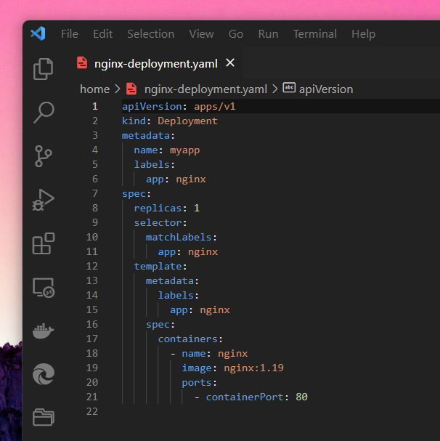

The design for the Pods can be found under “template.” The first specification tag is for deployments, while the second specification tag is for pods.

This configuration file basically specifies that we intend to bind one container inside the pod with an NGINX image to port 80.

When we use :

kubectl apply -f nginx-deployment.yaml

It utilises the settings to build a deployment. Let’s imagine that instead of creating one replica, the Deployment was altered in the configuration file to make four.

We receive the following output after executing kubectl get pod and kubectl get deployment :

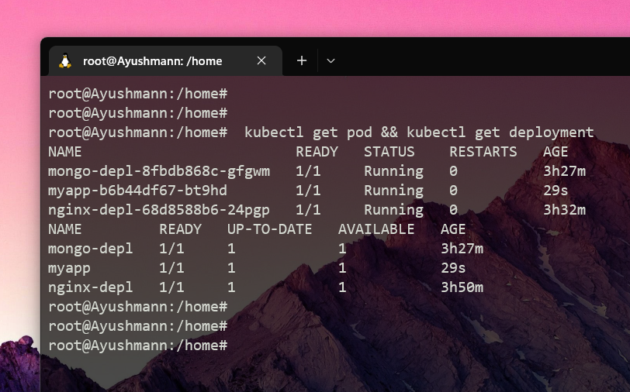

As you can see, K8s is capable of predicting when to create or update a deployment.

### Conclusion 🤔

You ought to learn a lot about Kubernetes’ foundations by reading this article. In conclusion, we discovered what Kubernetes is and its broad range of capabilities. We discovered the services that K8s offers as well as some crucial definitions. The next step was to investigate CRUD commands for Deployments using Docker and Kubectl. Finally, we learnt how to use configuration files for Deployments and debug Pods. It should be noted that any other K8s component, including services and volumes, can also be managed via kubectl.



### Final thoughts 💭

I sincerely hope you enjoyed reading along and gained some knowledge. I’m pleased you’ve made it this far since Kubernetes is a very helpful tool for managing containers. There is always much more comprehensive documentation available at <https://kubernetes.io/docs/home/>

Please let me know if I can go into more detail about this topic in the future, if you have any questions, or if I missed anything. Please leave me a comment; I truly appreciate it!

\\\

### GitHub URL for this article 💻

### Let’s connect and chat! Open to anything under the sun 🏖️🍹

**🐦 Twitter :** [devangtomar7](https://twitter.com/devangtomar7)  
**🔗 LinkedIn :** [devangtomar](https://www.linkedin.com/in/devangtomar)  
**📚 Stackoverflow :** [devangtomar](https://stackoverflow.com/users/8198097/devangtomar)  
**🖼️ Instagram :** [be_ayushmann](https://instagram.com/be_ayushmann)  
Ⓜ️ **Medium :** [Devang Tomar](https://medium.com/u/8f5e1c86129d?source=post_page-----e42119a306ca--------------------------------)  
☊ **Hashnode :** [devangtomar](https://devangtomar.hashnode.dev/)  
**🧑‍💻 Dev.to :** [devangtomar](https://dev.to/devangtomar)